注意：
- 升级软件必须与当前产品型号和硬件版本一致的软件；
- 升级过程中不能关闭路由器电源，否则可能导致路由器损坏；
- 升级时请使用有线方式连接，不要使用无线方式连接。

具体升级操作如下：
升级界面如下图：
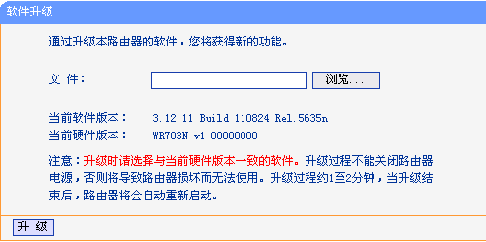
请按照以下步骤来升级：
1，进入设备的管理页面，然后进入“系统工具”－＞“软件升级”，点击“浏览”并选择要升级的.bin文件；
2，点击升级，升级成功后会有提示信息。

Translation
Note:
1, the software must be upgraded with the current product model and hardware version of the same software;
2, the upgrade process can not power down the router, the router may cause damage;
3, the upgrade to use the wired connection, do not use wireless connection.
Specific upgrade as follows:
Upgrade interface as shown below:
Follow these steps to upgrade:
1, into the device management page, then go to "System Tools" -> "software upgrade", click "Browse" and choose to upgrade. Bin file;
2, click upgrade, the upgrade will be successful message.

